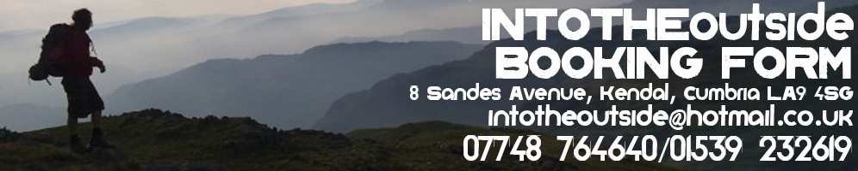
As INTO THE OUTSIDE will be responsible for your wellbeing, we require each individual to complete this form and return it by email to intotheoutside@hotmail.co.uk. (Please complete ALL BOXES in CAPTIALS)

Please reserve me a place on the ........................................... Event/Walk/Kayak/MTB/Canoe/Trek/Scramble/Climbing
Date(s)......................... at a cost of £......................... Where did you hear about INTO THE OUTSIDE?.................................

Your details:

Title:.............First name:......................... ............ Other names:................................Surname: ......................................................
Address:......................................................................................... ……… Postcode:..........................
Telephone:...................................................... E-mail:................................................................................................
DOB:..................... Next of Kin....................................:.............................
Their tel no:......................................................(Someone not on the adventure)

Medical Information form:

Have you been a hospital patient during the past 12 months? YES/ NO
Have you received doctor’s treatment during the past 12 months? YES/ NO
Are you receiving or waiting for hospital treatment? YES/ NO
Do you suffer from any allergies? YES/ NO
Have you ever suffered from; heart disease, high blood pressure, asthma, epilepsy, diabetes? YES/ NO
Are you taking any drugs or other medication? YES/ NO
Have you ever had problems with your back or with any joints (knees etc)? YES/ NO
Is there anything else you feel Into The Outside should be made aware of? YES/ NO

If you have answered YES to any question please give details in the below. Please continue on the back of this form if you require more space. …………………………………………………………………………………………………………………………………………………………………………………

Are you confident swimming 50 metres? (only complete if doing Kayak/Canoe or Ghyll Scramble) YES/NO
The photos we use on your adventure may be used on our website! Is this OK? YES/NO
Can we contact you again to share upcoming adventures? YES/NO

Minimum Age

The Minimum Age for our walks is 18 years of age, under 18’s must be accompanied by a parent or guardian.

Participation Statement

INTO THE OUTSIDE recognise that mountain walking, canoeing, mountain biking and kayaking are activities with a danger of personal injury or death. Participants should be aware of and accept these risks and be responsible for their own actions and involvement.

Booking form declaration

• By making a booking you are deemed to have agreed to the following conditions and participation Statement (above):
• You have read and accepted these booking conditions
• You are suitably equipped and fit for the activity, and you acknowledge and accept the dangers associated with outdoor / activities (see above)
• You do not suffer from any pre-existing medical conditions that may prevent active participation in the activity.

Signed:............................................................ Print name:.................................................................. Date:.............Road, Ambleside, Cumbria, LA22 0DB, UK. Tel: 015394

